Lab Objective

Learn how to configure RADIUS accounting which admins can use to track network usage for auditing purposes

**Lab Procedures**

**1.** On RWDC01, using the Network Policy Server console, on the NPS tree, click Accounting.

**2.** In the Accounting section, click Configure Accounting. When the Accounting Configuration Wizard starts, click Next.

**3.** On the Select Accounting Options page (as shown in Figure 12-4), click *Log to a text file on the local computer* and click Next.

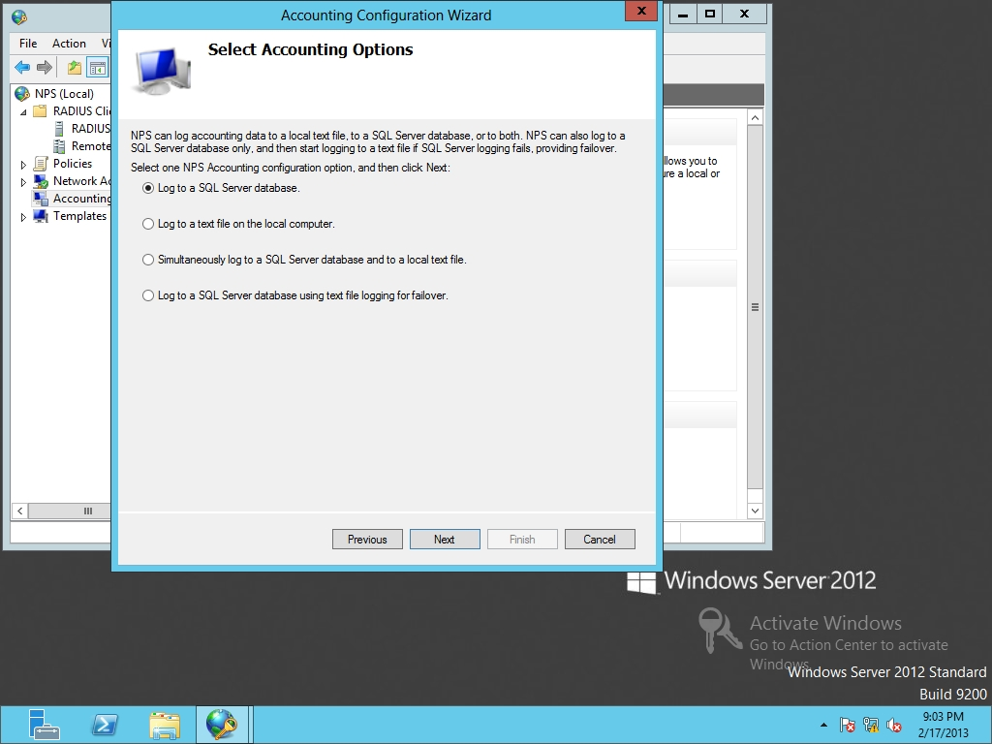

Figure 12-4

Selecting accounting options

**4.** On the Configure Local File Logging page, answer the following question and click Next.

**5.** On the Summary page, click Next.

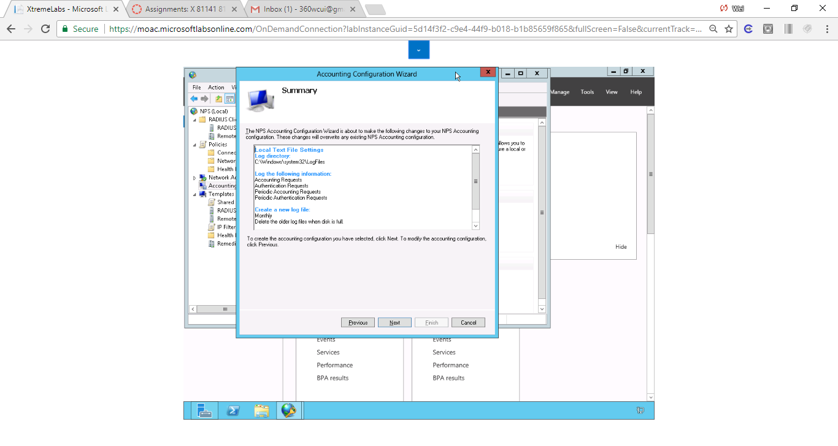

Figure 1 Screenshot shows the Summary Page after the RADIUS account is set up properly based on the lab procedures.

**6.** On the Conclusion page, click Close.

**Lab Summary**

During this exercise, I learned how to configure RADIUS accounting which allows admins to track the network usage for audit purposes. There are two methods to record events in RADIUS accounting: log files and SQL database. By default, the logs are saved in

C:\Windows\system32\LogFiles